GET JSON-SERVER:

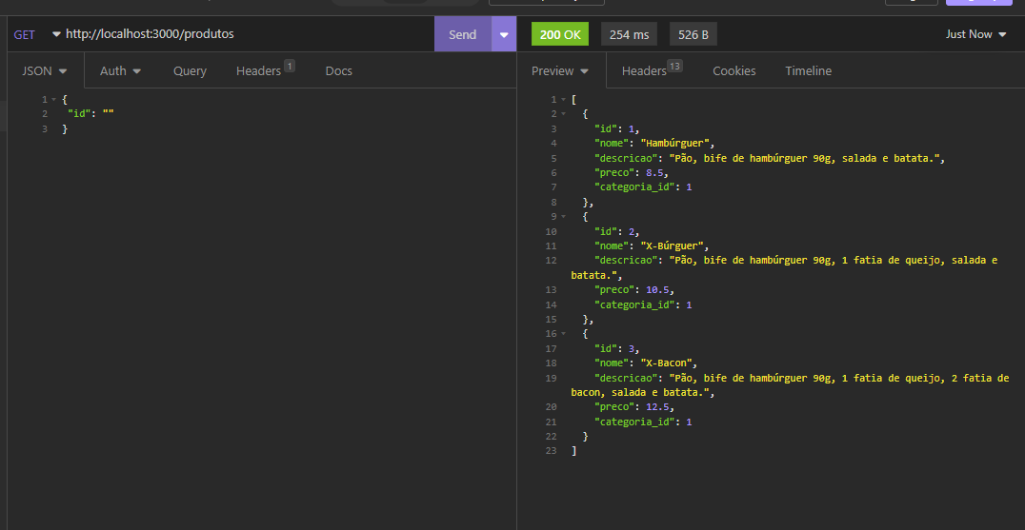

POST JSON-SERVER:

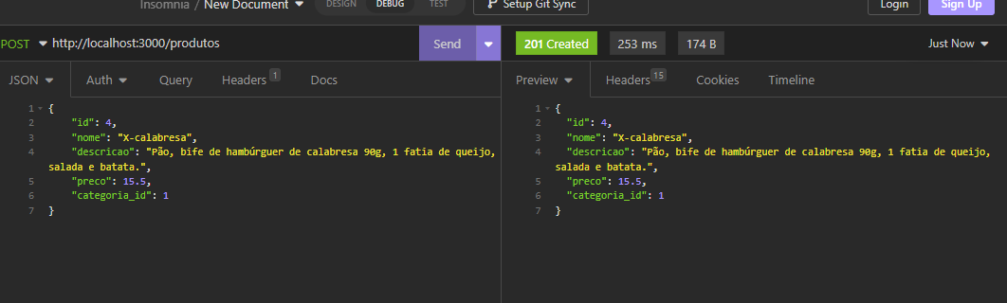

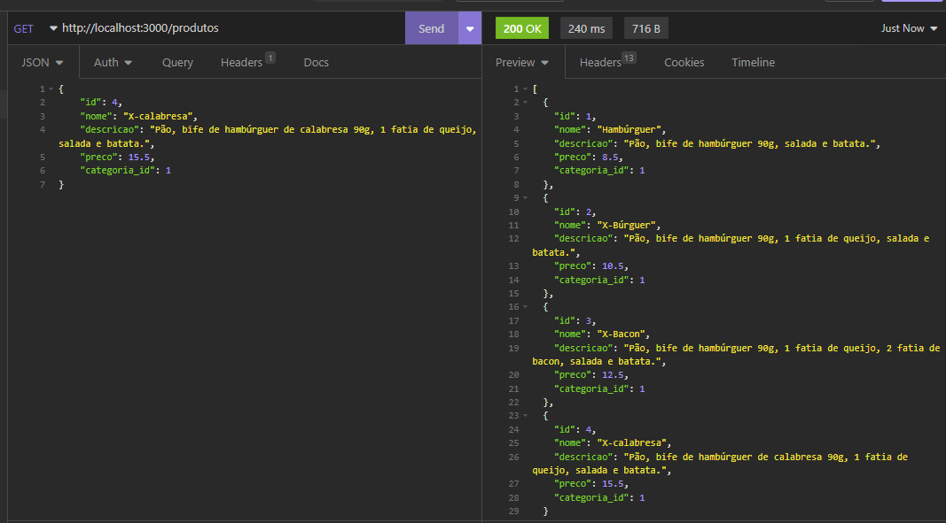

PUT JSON SERVER: ATUALIZANDO PREÇO ID 1

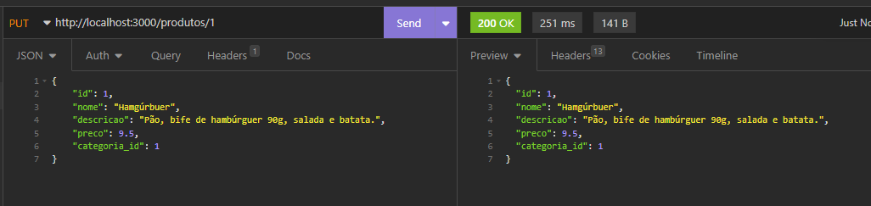

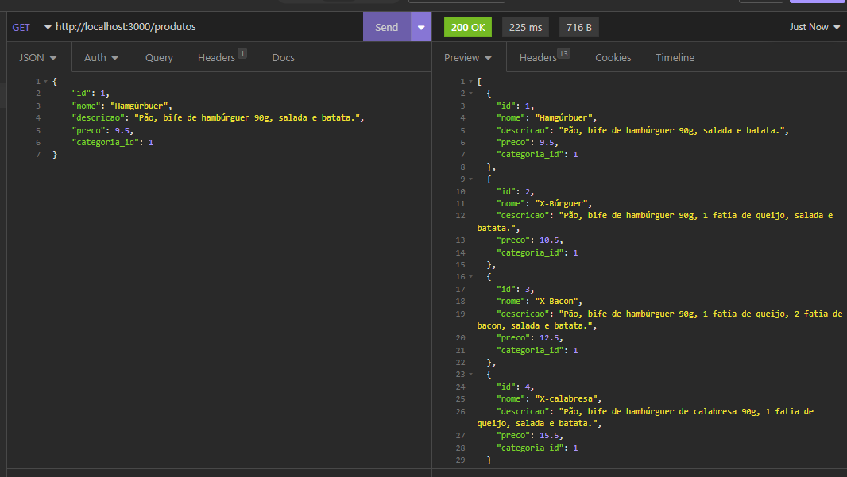

DELETE JSON-SERVER: DELETANDO ID 4

